

United States International University

MIS 6020: Application Domains of IT

Application Software Exercise

Achieving Operational Excellence: Building a Relational Database for Inventory Management.

In this exercise, you will use database software to design a database for managing inventory for a small business Bike Shop that sells road, mountain, hybrid, leisure, and children’s bicycles. Currently, they purchase bikes from three suppliers but plan to add new suppliers in the near future. This rapidly growing business has a database system that needs management of this information. Initially, the database houses information about suppliers and products. The database contains two tables: a supplier table and a product table.
The re-order level refers to the number of items in inventory that triggers a decision to order more items to prevent a stock out. (In other words, if the number of units of a particular item in inventory falls below the reorder level, the item should be reordered). The user should be able to perform a number of queries and produce several managerial reports based on the data contained in the two tables. Perform the following activities:
- Prepare a report that identifies the five most expensive bicycles. The report should list the bicycles in descending order from most expensive to least expensive, the quantity on hand for each, and the mark-up percentage for each bicycle type.
- Prepare a report that lists each supplier, the products they supply, the quantities on hand and associated re-order levels. The report should be sorted alphabetically by supplier. Within each supplier category, the products should be sorted alphabetically.
- Prepare a report listing only the bicycles that are low in stock and need to be re-ordered.
- The report should provide supplier information for the items identified.

Step 1:Creating Queries.
- Create a query to find out the bicycles that are low in stock by selecting the table, clicking on the CREATE tab and selecting the Query Wizard option.
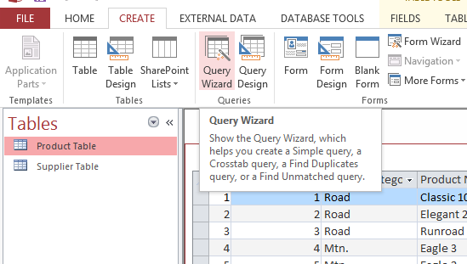
The dialog appears. Select the Simple Query Wizard and click OK
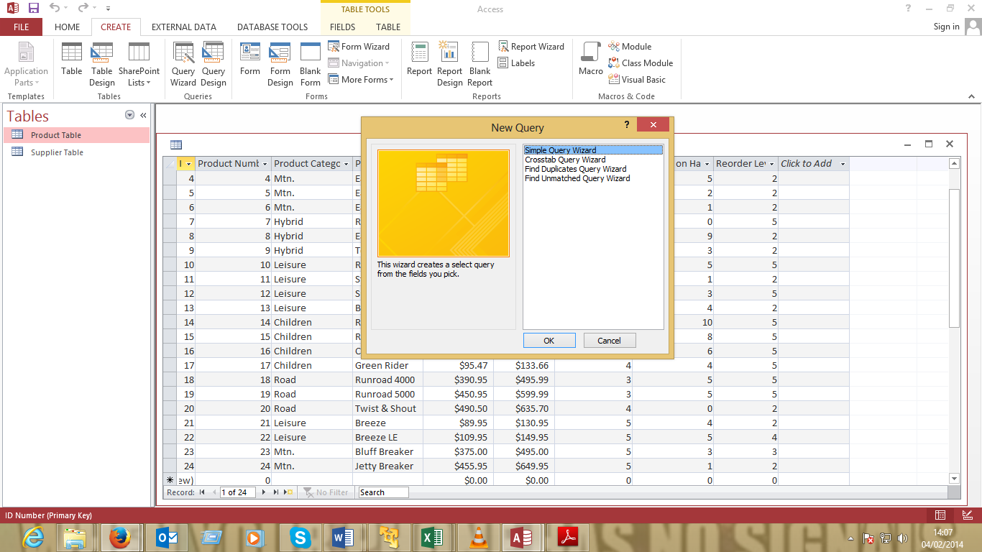
The Wizard with the tables and fields in the table appears.
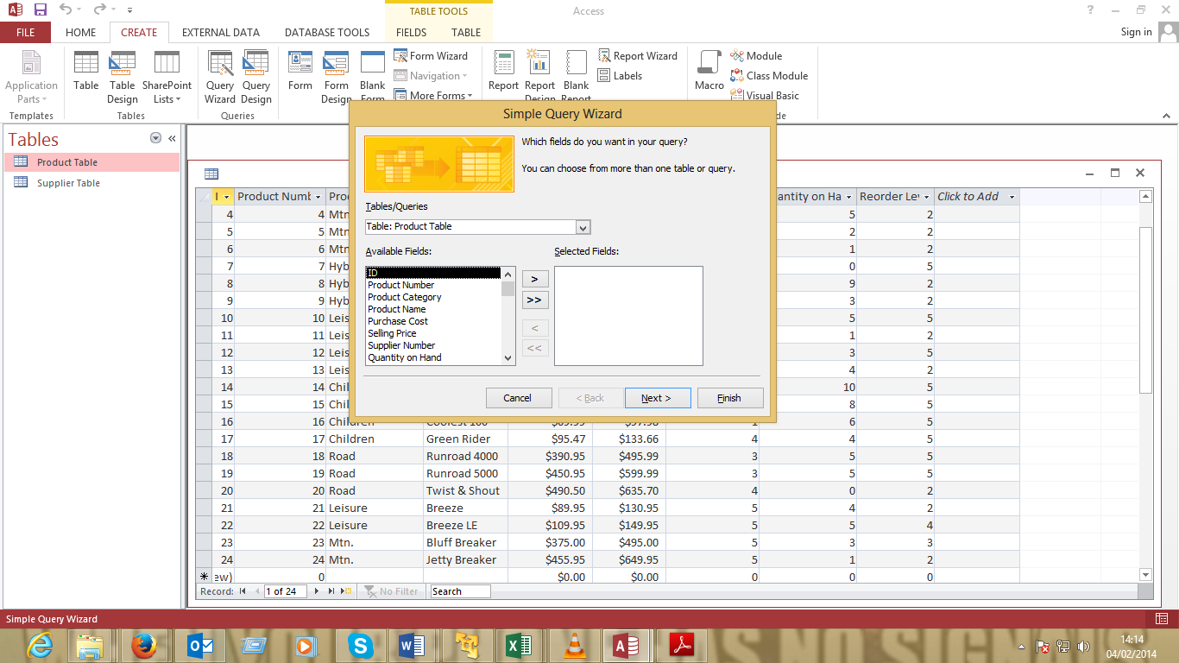
Step 2: Adding fields to be displayed
- Select the fields Product Name, Product Number and supplier number from the product table and move them to the selected fields as shown below.
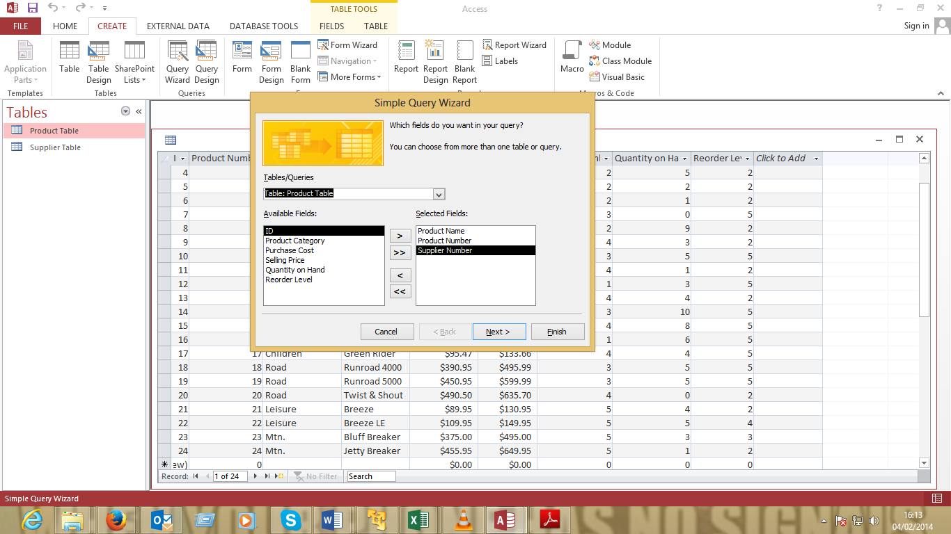
- On the Tables/Queries drop down select the Suppliers table and move the fields Company name, Street address City State and zip code as shown
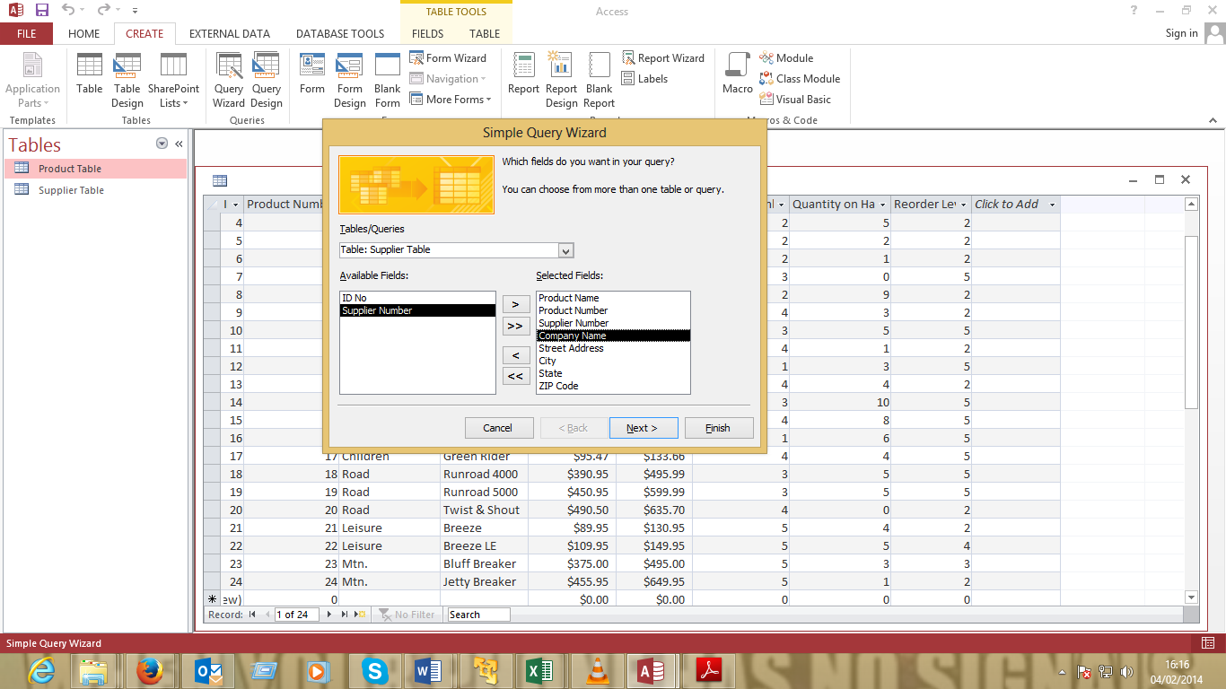
- Go back to the Tables/Queries drop down, select the Products Table and move the Quantity on hand and re-order level fields to the selected field items.
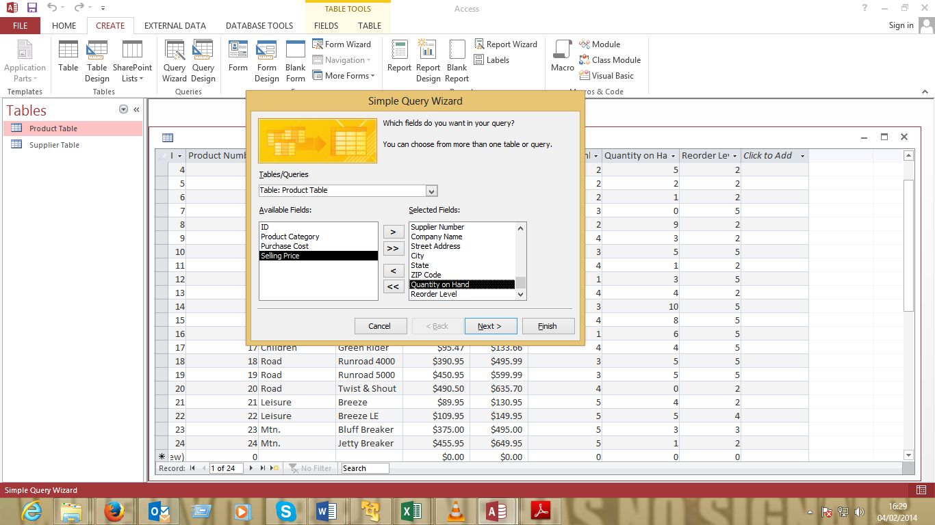
Step 3: Type of queries
- Select Next, the dialog appears. Select the type of query in our case select the detail option.
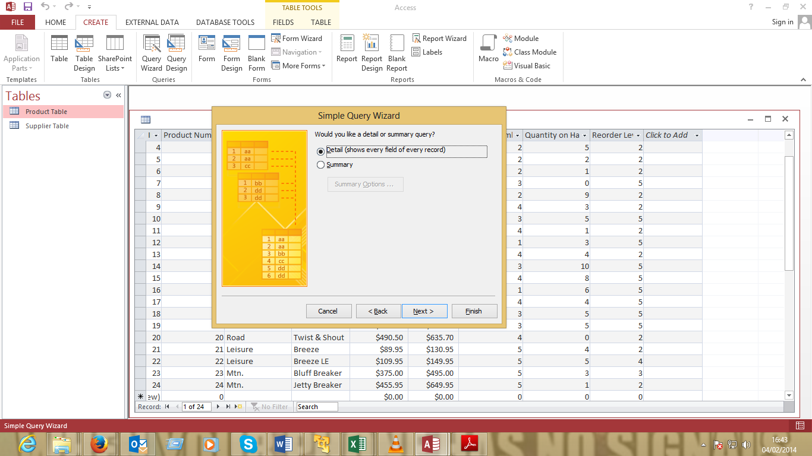
Step 4: Naming the Query
- Click next. Change the Tiltle of the query to Bicycles Low in Stock and select the Modify the Query Design.
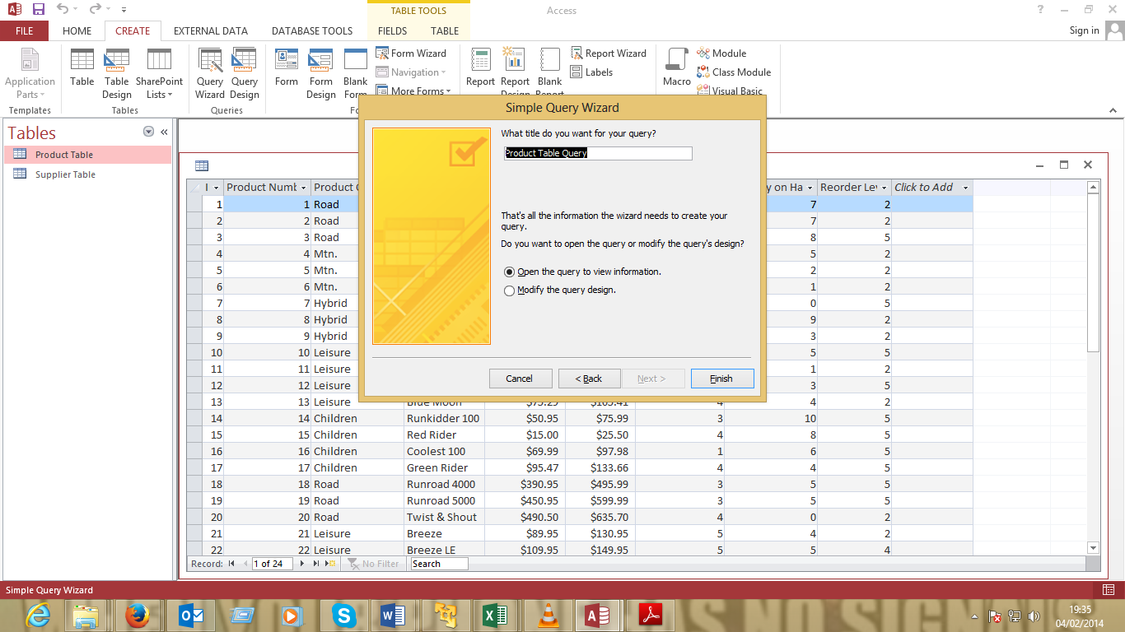
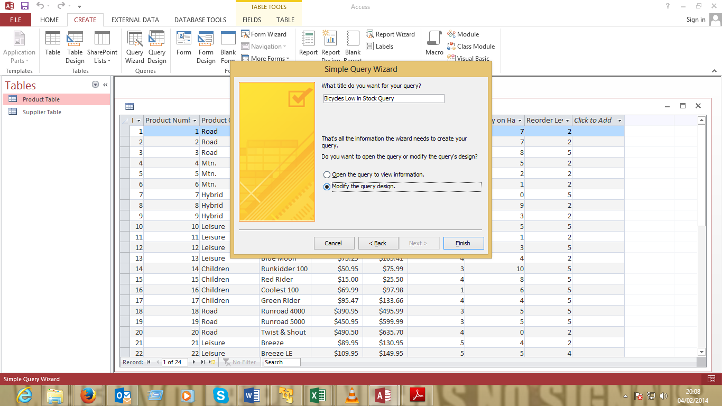
Step 5: Adding the conditions for the query
- The Query is opened in Design View. Now we need to modify the field criteria to match our aim which is to display the bicycles that are low in stock.
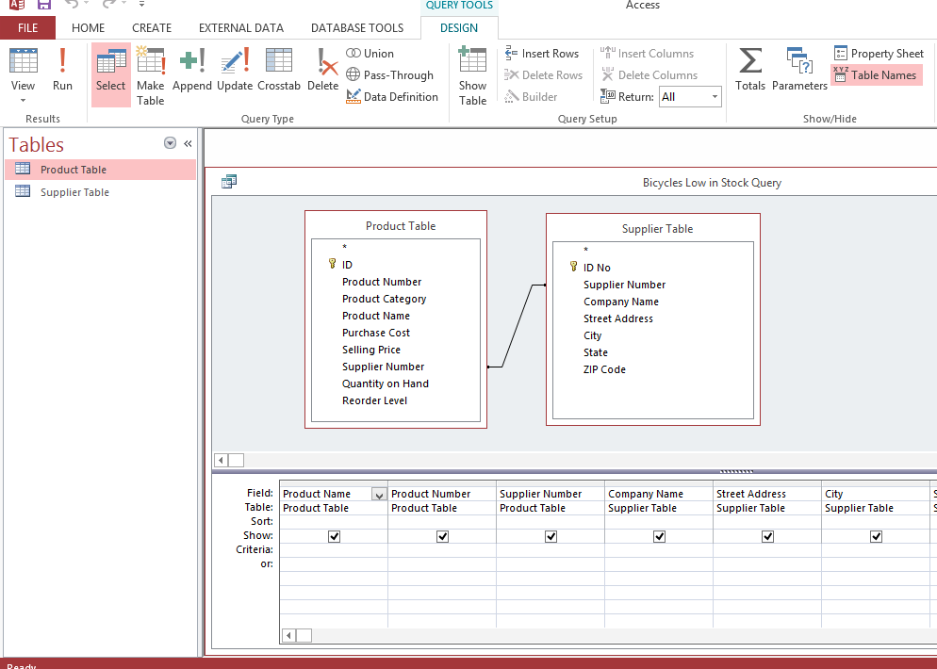
CREATING QUERIES WITH QUERY BUILDER
- Click on the empty field after the Re-order Level field. The query tools menu appear. Select the builder icon on the ribbon to launch the query builder so that we set the query to find out the diference between quantity in hand and the reorder level.
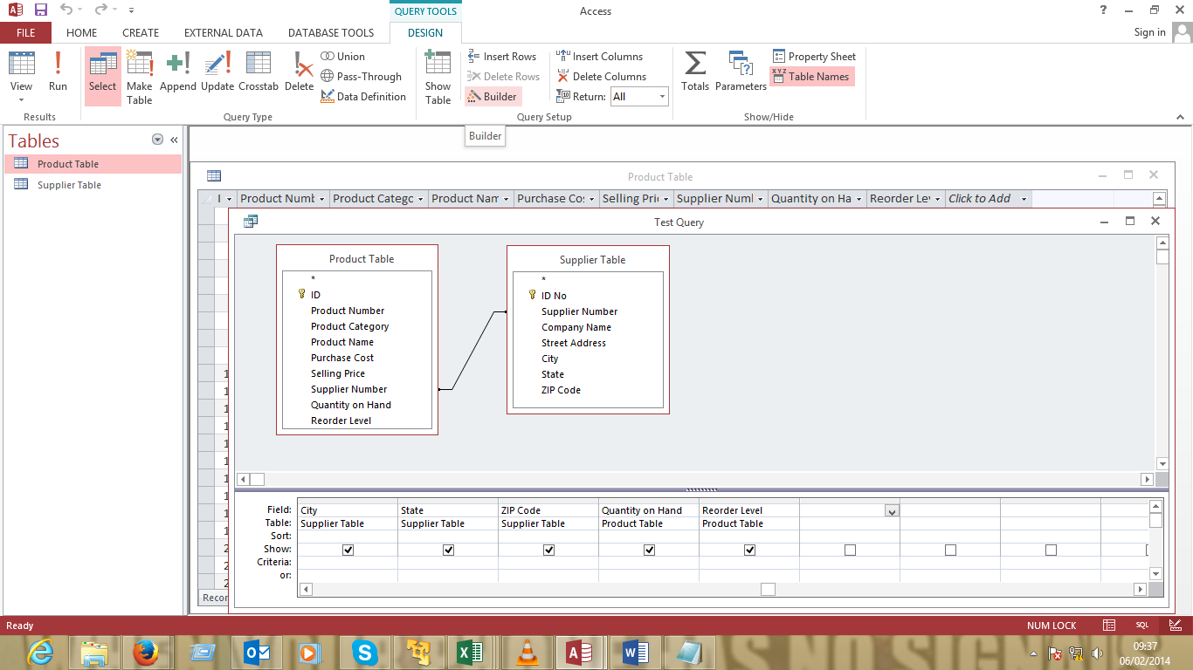
The query builder dialog appears.
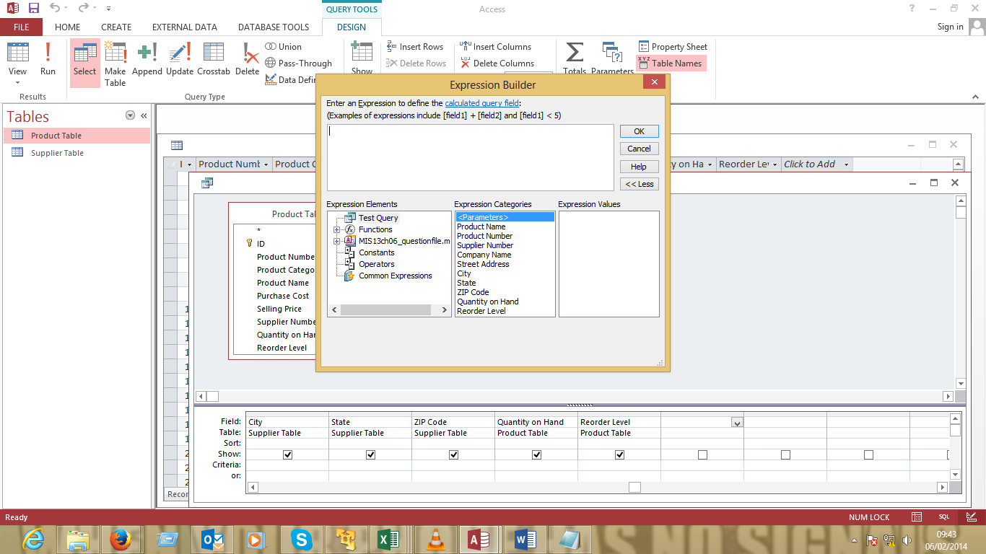
Step 6: Building the query
- On the Expression Elements expand the database and select the Product Table. Select the Re-order Level and double click on it to add it to the query.
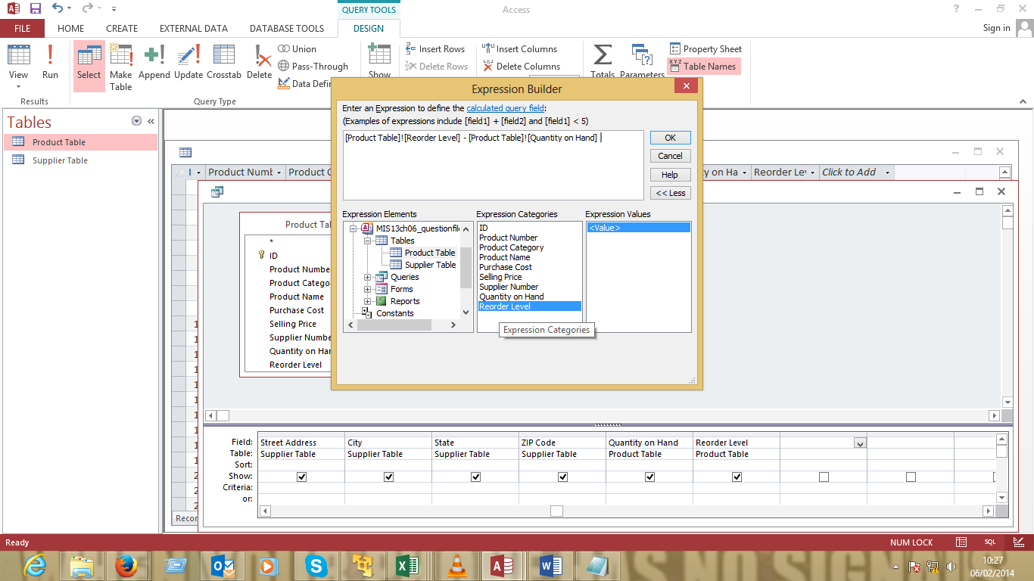
- On the Expression Elements scroll down to operators and on the expression categories select arithmetic. Double click on the minus sign to add it to the query.
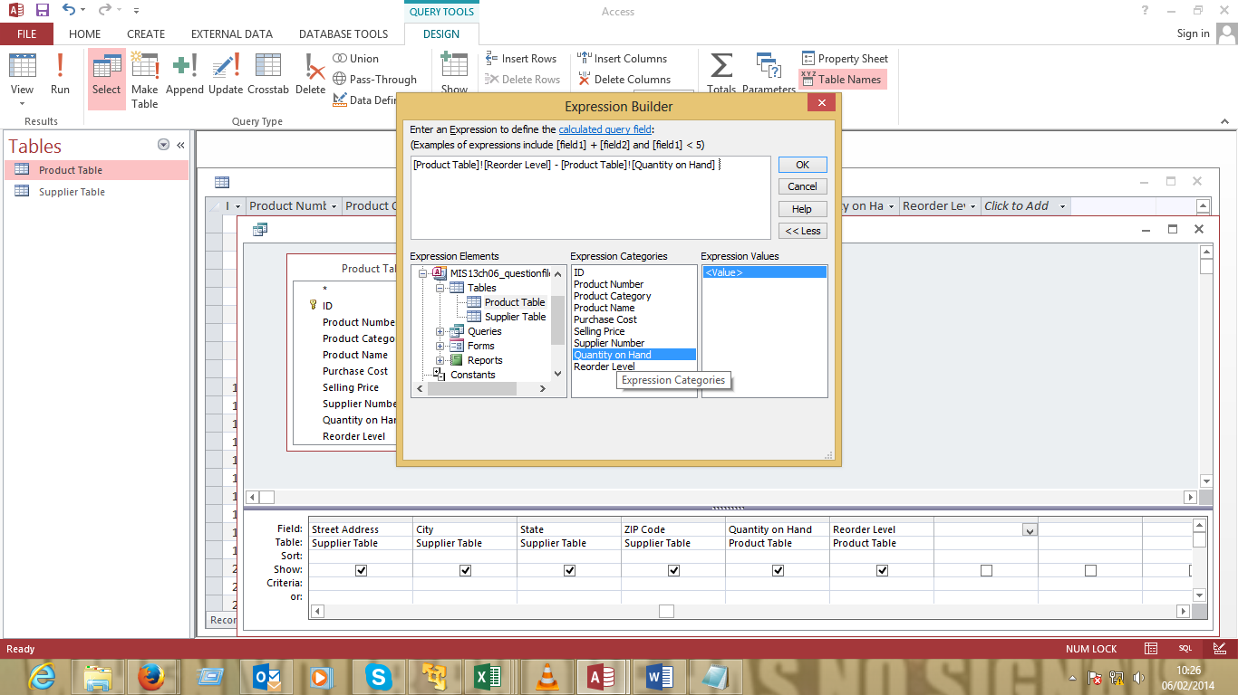
- Scroll back to the database and select the Product Table. This time select the Quantity on Hand and double click on it to add it to the query.
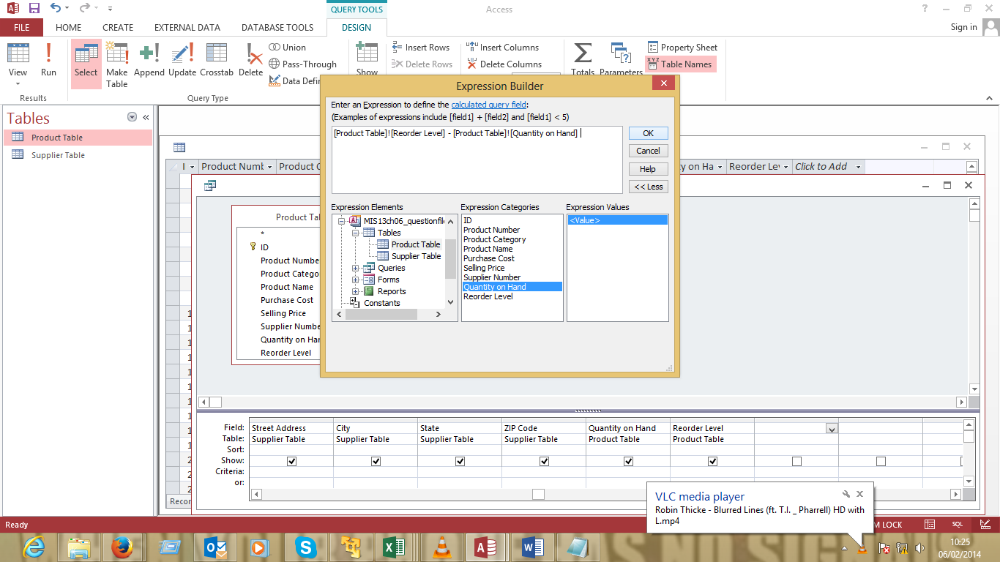
- When done with the query click on the OK button to close the builder dialog.
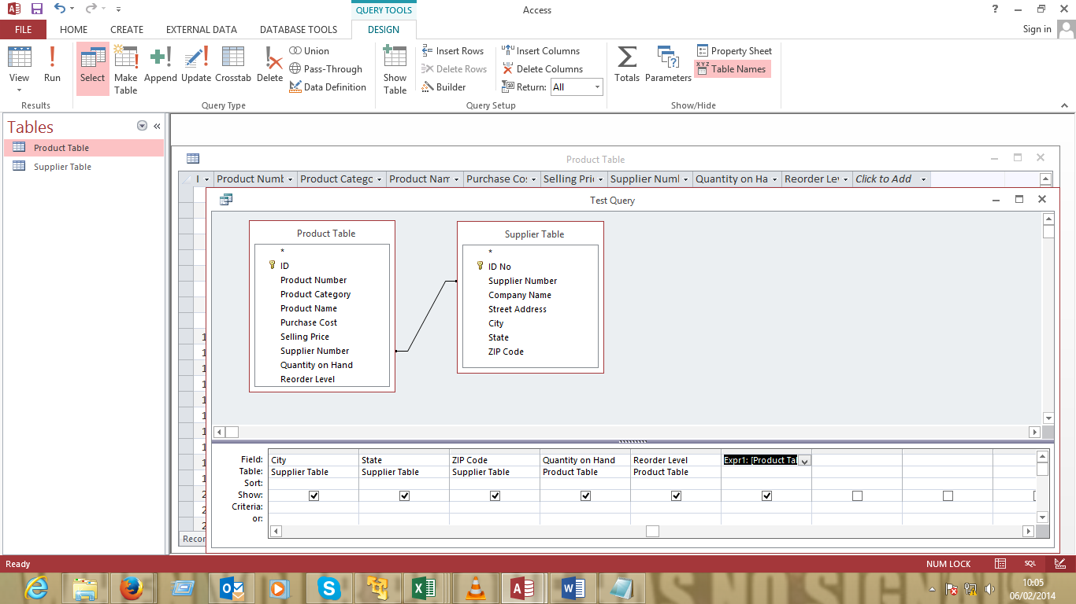
- On the critera field add the expression >0. This is to make the query display only the diference that is greater than 0, meaning the stock level is low.

Once you are done changing the criteria, change the view from Design view to Datasheet View to see the results.
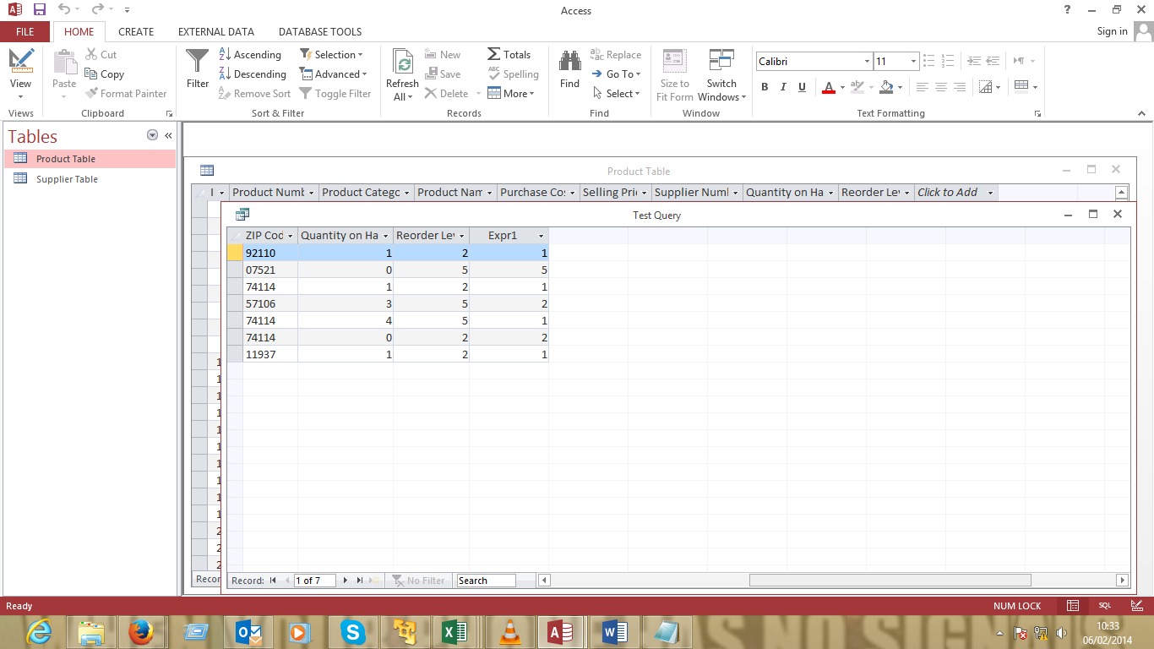

REPORT CREATION
- Creating a report for the bicycles low on stock involves the following steps.
Step 1: Seleect the Product table, select the CREATE tab and click on the Report Wizard.
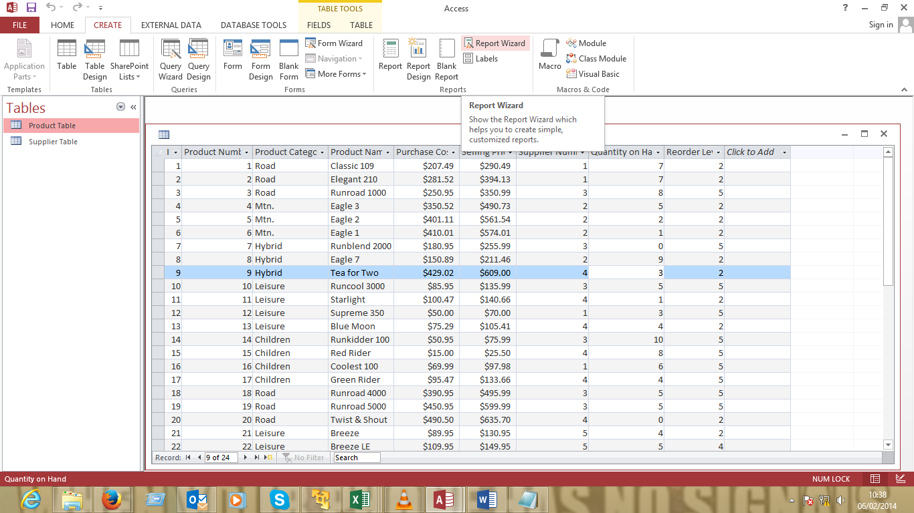
Step 2: Selecting the fields to display
The report wizard launches.
- Select the query that was previously created and drag all fields to the selected fields then
click Next
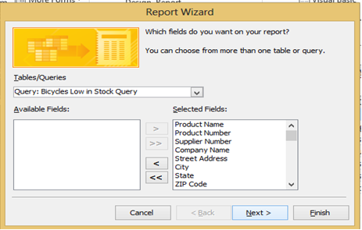
- Click on the Next button and leave the defaults.
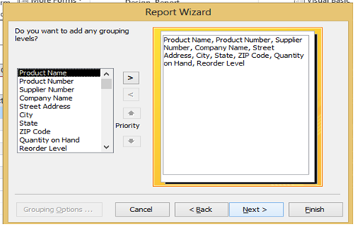
- Leave the defailts for the next step
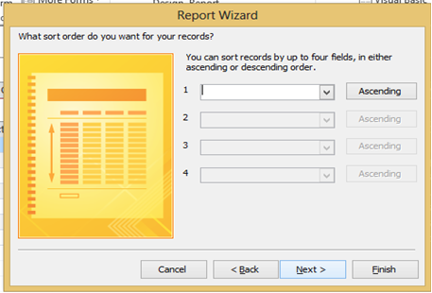
- Select the layout and orientation for the report. Since this is a simple report use the potrait orientation and tabular layout.
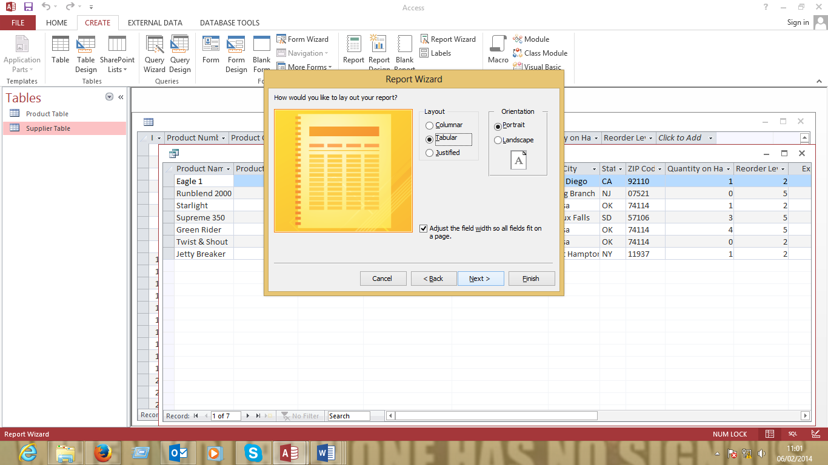

- Give the report a title and leave the defaults and finish the wizard. The report appears
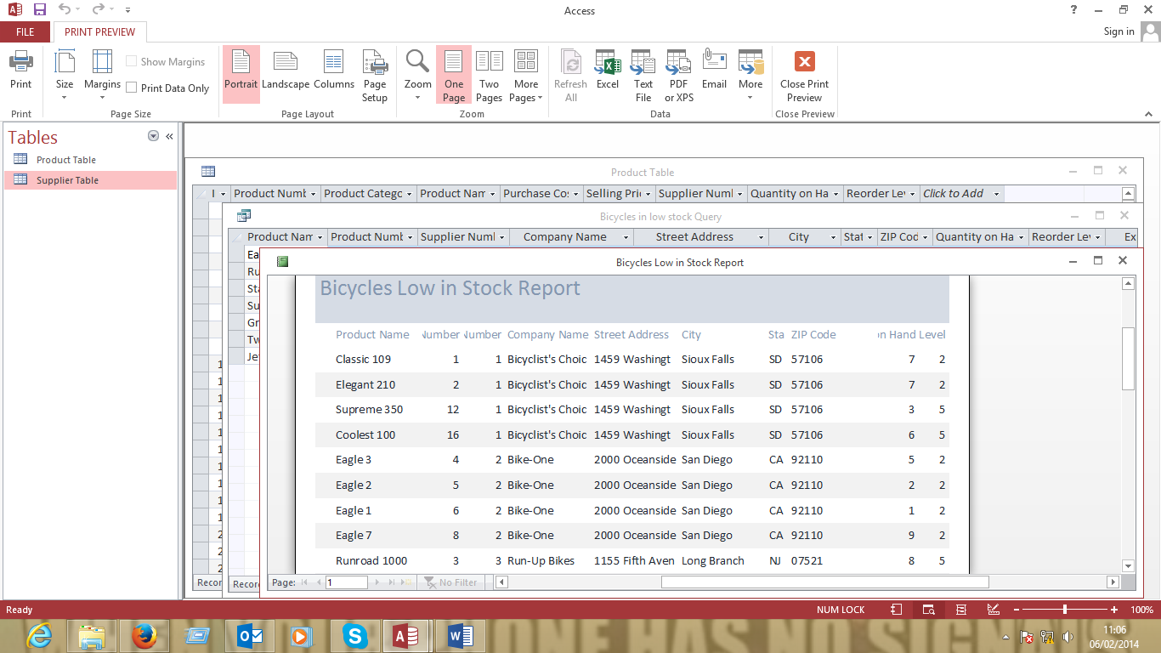
Additional Tasks
- Create a query to show the product and supplier information
- Create a query to show the five lowest prices for bicycles
- Create a report to show the product and supplier information
- Create a report to show the five lowest prices for bicycles.

